3.
abstract class Energy_source {
int source_id;
String source_name;
double energy_generated;
Energy_source(int si, String sn, double eg) {
source_id = si;
source_name = sn;
energy_generated = eg;
}
abstract void calculate_efficiency();
}
class solar_energy extends Energy_source {
solar_energy(int si, String sn, double eg) {
super(si, sn, eg);
}
@Override
void calculate_efficiency() {
System.out.println("name:Krishna Kumar Agrawal USN:1BF25CS128");
System.out.println("The source ID is " + source_id);
System.out.println("The source name is " + source_name);
System.out.println("The solar efficiency is "
+ ((energy_generated / 5000) * 100) + "%");
}
}
class wind_energy extends Energy_source {
wind_energy(int si, String sn, double eg) {
super(si, sn, eg);
}

@Override
void calculate_efficiency() {
System.out.println("The source ID is " + source_id);
System.out.println("The source name is " + source_name);
System.out.println("The wind efficiency is "
+ ((energy_generated / 8000) * 100) + "%");
}
}
class run {
public static void main(String[] args) {
solar_energy se = new solar_energy(432, "solar panel", 50000.0);
se.calculate_efficiency();
System.out.println();
wind_energy we = new wind_energy(433, "wind turbine", 40000.0);
we.calculate_efficiency();
}
}
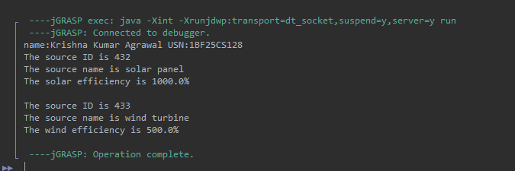

4.

interface ParkingCharge {
double calculateCharge();
void displayParkingDetails();
}
class VehicleParking {
String vehicleNumber;
String vehicleType;
int parkingHours;
public VehicleParking(String vehicleNumber, String vehicleType, int parkingHours) {
this.vehicleNumber = vehicleNumber;
this.vehicleType = vehicleType;
this.parkingHours = parkingHours;
}
}
class TwoWheeler extends VehicleParking implements ParkingCharge {
public TwoWheeler(String vehicleNumber, int parkingHours) {
super(vehicleNumber, "Two Wheeler", parkingHours);
}
public double calculateCharge() {
if (parkingHours <= 2) {
return parkingHours * 20.0;
} else {
return (2 * 20.0) + ((parkingHours - 2) * 10.0);
}
}

public void displayParkingDetails() {
System.out.println("Name:Krishna Kumar Agrawal ,USN:1BF25CS128");
System.out.println("Vehicle Number: " + vehicleNumber);
System.out.println("Vehicle Type: " + vehicleType);
System.out.println("Parking Hours: " + parkingHours + " hrs");
System.out.println("Total Parking Charge: Rs. " + calculateCharge());
System.out.println("-----------------------------------");
}
}
class FourWheeler extends VehicleParking implements ParkingCharge {
public FourWheeler(String vehicleNumber, int parkingHours) {
super(vehicleNumber, "Four Wheeler", parkingHours);
}
public double calculateCharge() {
if (parkingHours <= 2) {
return parkingHours * 50.0;
} else {
return (2 * 50.0) + ((parkingHours - 2) * 30.0);
}
}
public void displayParkingDetails() {
System.out.println("Vehicle Number: " + vehicleNumber);
System.out.println("Vehicle Type: " + vehicleType);
System.out.println("Parking Hours: " + parkingHours + " hrs");
System.out.println("Total Parking Charge: Rs. " + calculateCharge());
System.out.println("-----------------------------------");
}
}
public class ParkingManagementSystem {
public static void main(String[] args) {
ParkingCharge parkingRef;
parkingRef = new TwoWheeler("KA-01-AB-1234", 5);
parkingRef.displayParkingDetails();
parkingRef = new FourWheeler("KA-05-CD-5678", 4);
parkingRef.displayParkingDetails();
}
}

